**FEUILLE DE ROUTE**



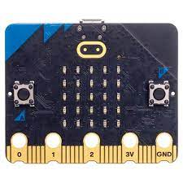

_ _ _ _ _ _ _

_ _ _ _ _ _ _ _ _ _





_ _ _ _ _ _ _ _

_ _ _ _ _ _ _ _

_ _ _ _ _ _ _

_ _ _



_ _ _ _ _ _ _ _

Une fois ces ElEments renseignEs,

FAITES LES VALIDER PAR LE MAITRE DU JEU …

 !